TASK #01:

ORG 100H

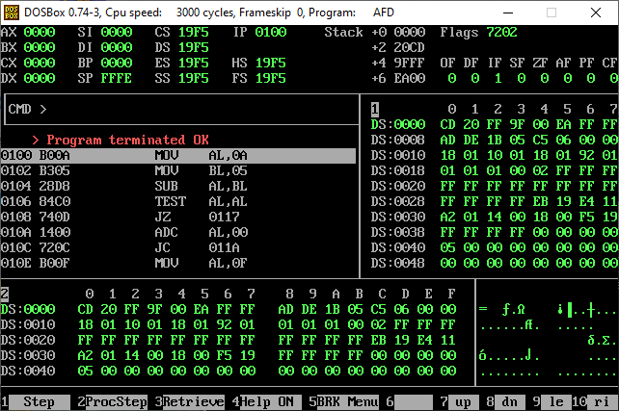MOV AL, 10

MOV BL, 5

SUB AL, BL

TEST AL, AL

JZ ZeroFlagSet

ADC AL, 0

JC CarryFlagSet

MOV AL, 0FH

ADD AL, 01H

MOV AX, 4C00H

INT 21H

ZeroFlagSet:

JMP EndProgram

CarryFlagSet:

JMP EndProgram

EndProgram:

MOV AX, 0x4C00

INT 0x21

TASK #02:

ORG 100h

MOV AL, 0x0F

MOV BL, 0x01

ADD AL, BL

TEST AL, AL

JZ ZeroFlagSet

ADC AL, 0

JC CarryFlagSet

MOV AL, 0FH

ADD AL, 01H

MOV AX, 4C00H

INT 21H

ZeroFlagSet:

JMP EndProgram

CarryFlagSet:

JMP EndProgram

EndProgram:

MOV AX, 0x4C00

INT 0x21

TASK #03:

ORG 100h

MOV AL, 0x0F ; 00001111

MOV BL, 0x01 ; Adding 1 will cause carry from bit 3 to 4

CMP AL, BL ; Result = 10h, AF should be set

TEST AL, AL

JZ ZeroFlagSet

JC CarryFlagSet

MOV AL, 0FH

ADD AL, 01H

MOV AX, 4C00H

INT 21H

ZeroFlagSet:

JMP EndProgram

CarryFlagSet:

JMP EndProgram

EndProgram:

MOV AX, 0x4C00

INT 0x21